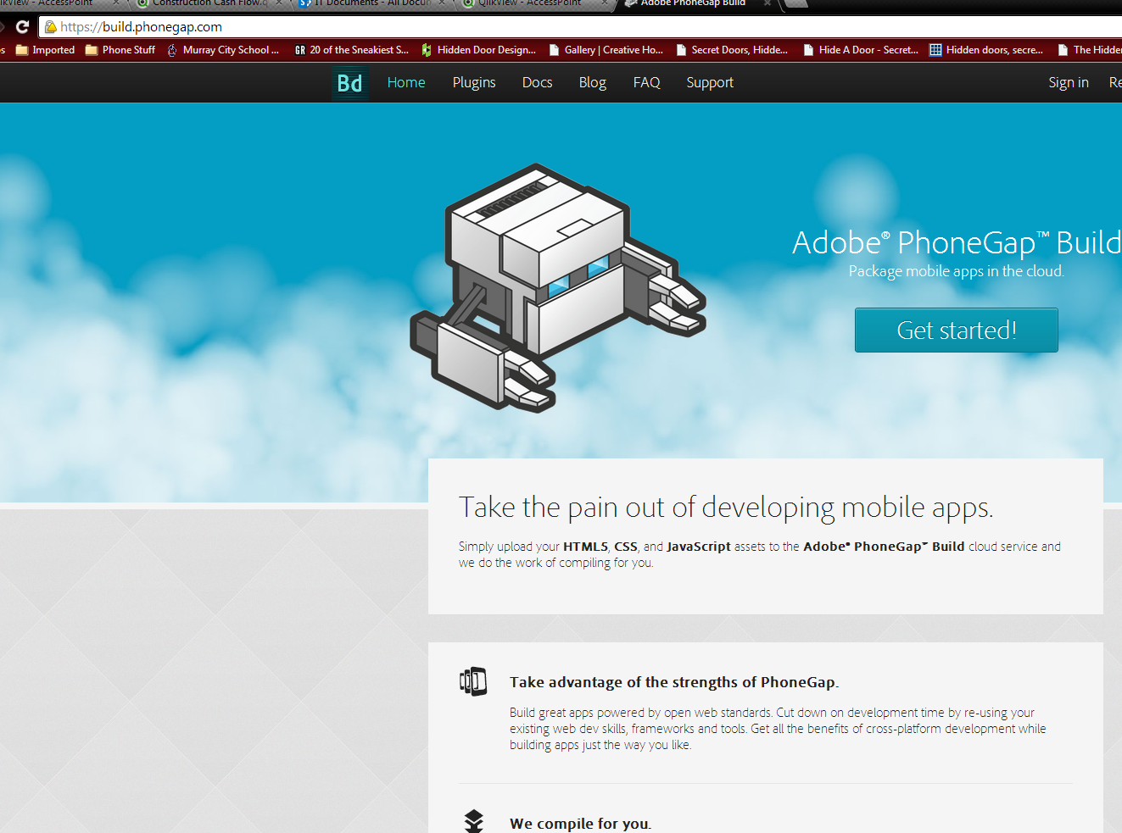

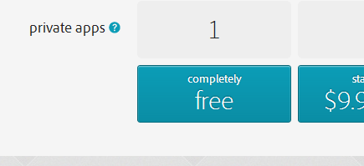

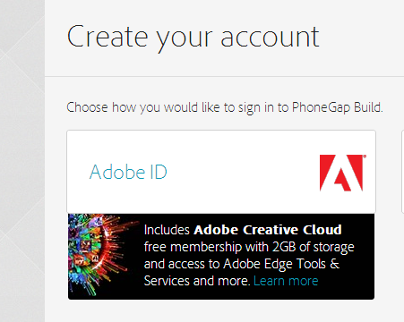

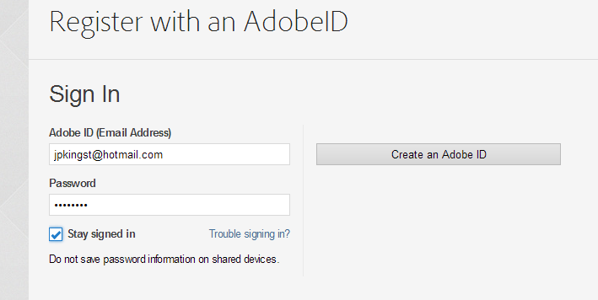

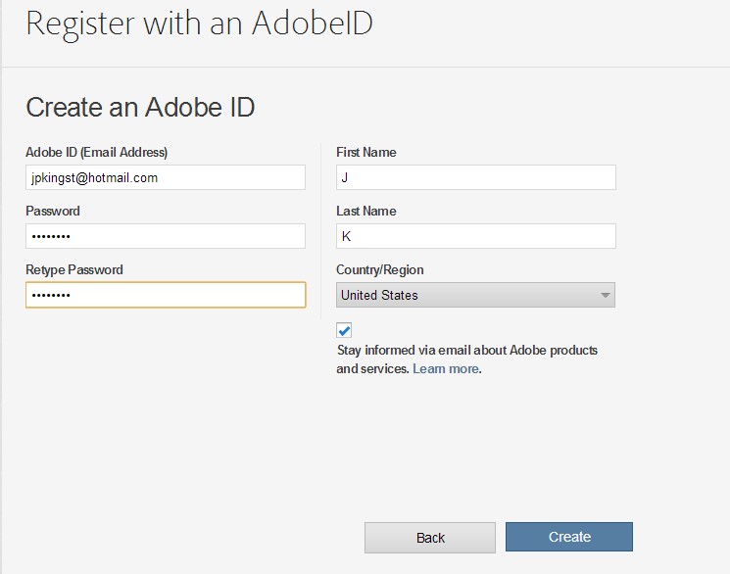

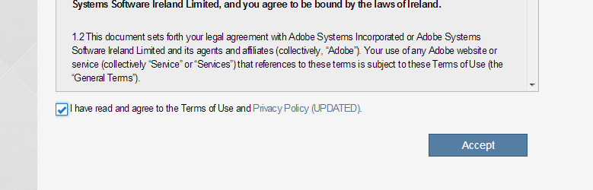

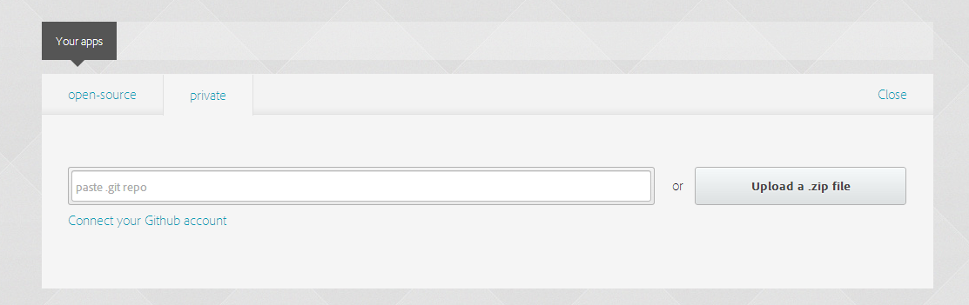

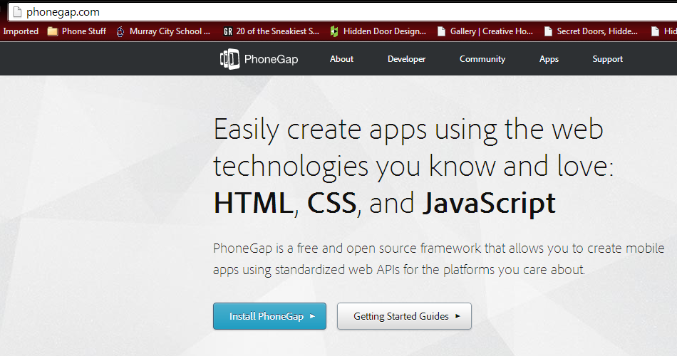

Click Get Started

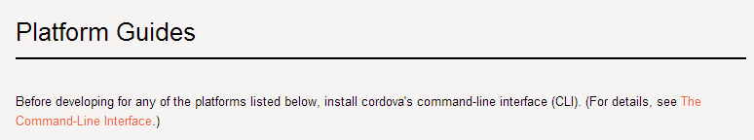

click Command-line Interface

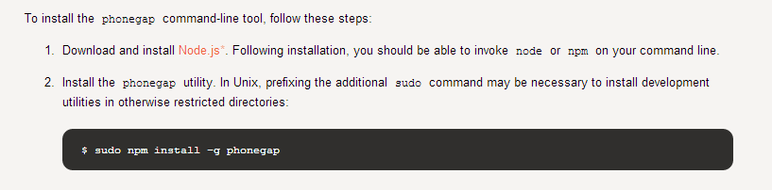click Node.js

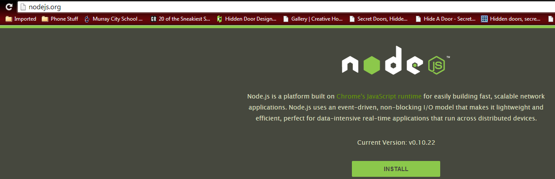

Click install

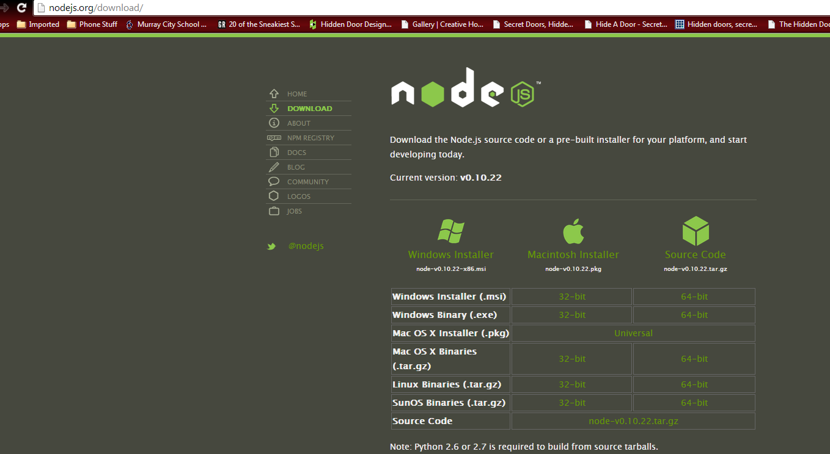

click windows installer

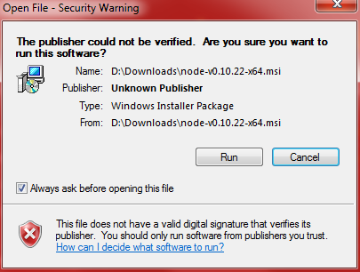

Accept license agreement

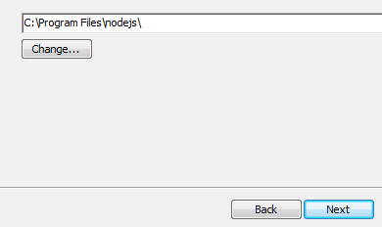

Click Next

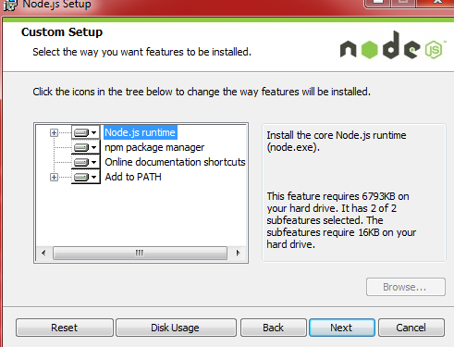

Click Next

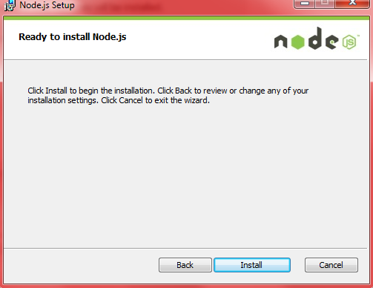

Click Install

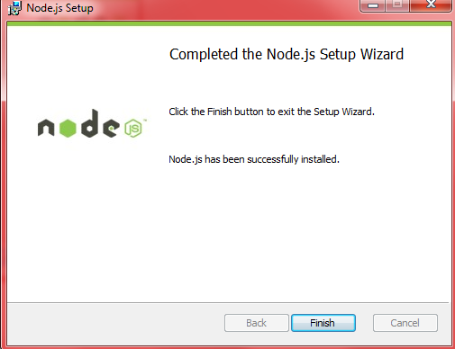

Click Finish

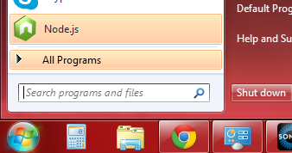

Start Node.js

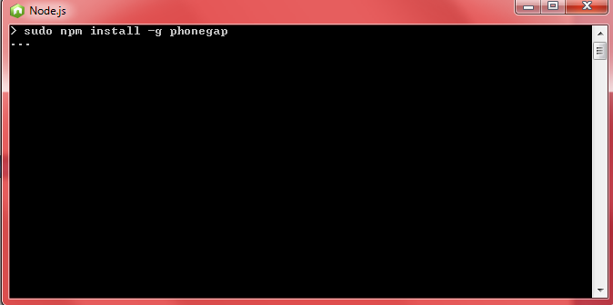

type "npm install -g phonegap" (Sudo is needed only for mac and linux command line)

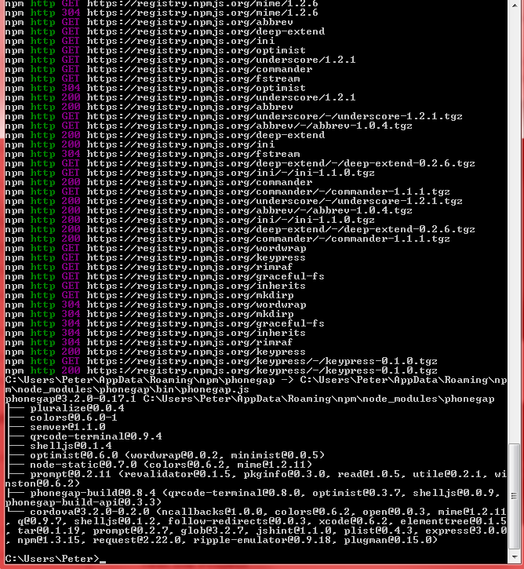

Type ruby -e "$(curl -fsSL [raw.github.com/mxcl/homebrew/go/install)"](https://raw.github.com/mxcl/homebrew/go/install)%22);

Into command line

Then type brew install ant

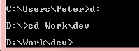

cd D:\Work\dev

Now you're ready to start you're own phonegap application.

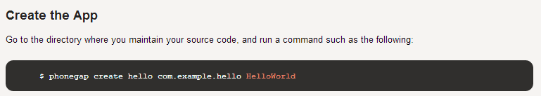

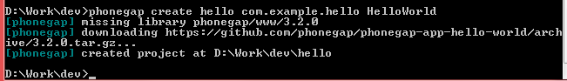

When download is finished find the downloaded file and install it

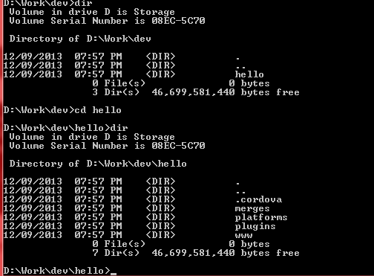

Build the app on ios

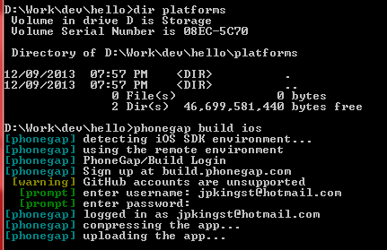

type in your build.phonegap.com or your creative cloud account and password

Browse to your build.phonegap.com and refresh your apps

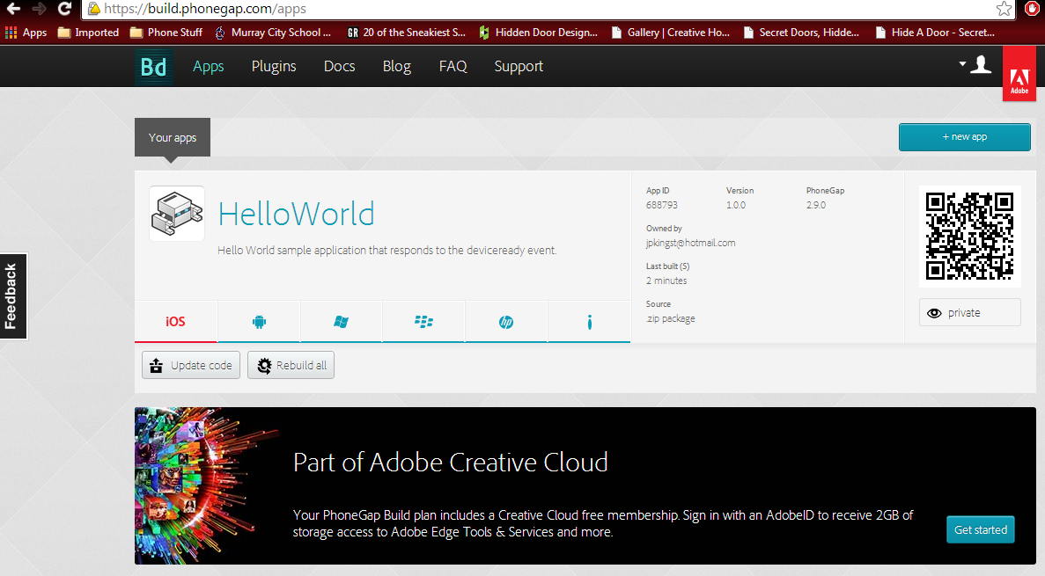

now scan this code with your android or ios phone to install this app.

Download and install Aptana Studio 3

Start Aptana Studio 3

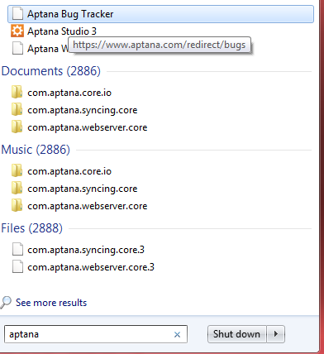

Create new web project

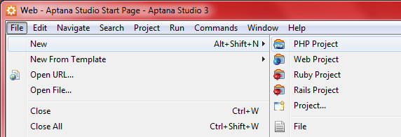

Click create new project,

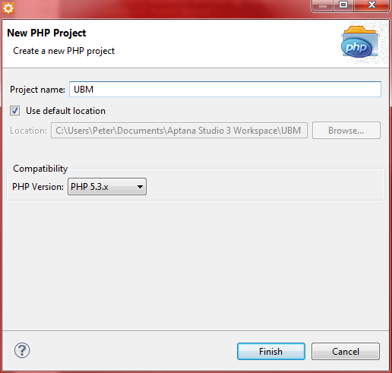

Name the project

Select Explorer, and expand ubm, right click on connections select add new connection

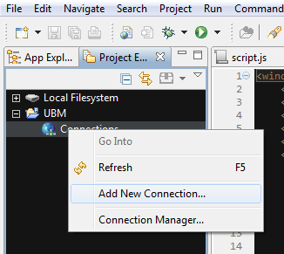

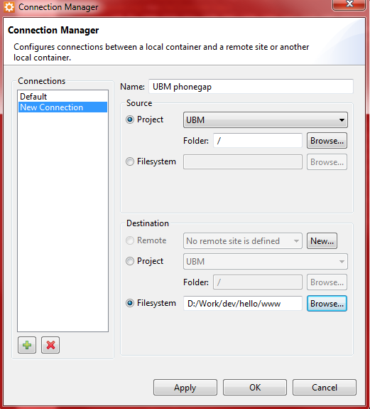

Name your connection, select filesystem at the bottom and redirect to your hello world project www directory. <Apply> <OK>

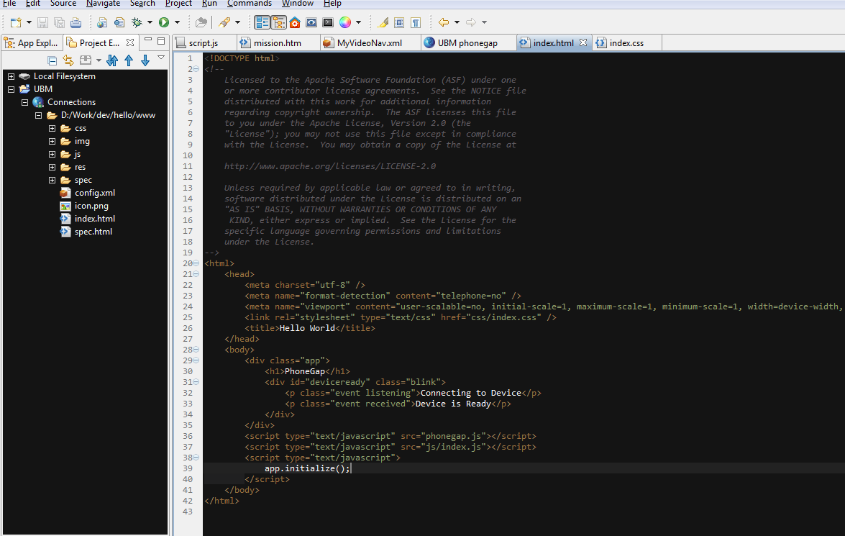

open up the index.html file in the www directory and you can see the code generated by phonegap that is running the app.

Now open a web browser and go to jquerymobile.com/download/

NOW add jquery javascript css to your

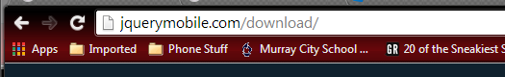

Copy and paste this into your index.html header and it will include the hosted .css files from jquery servers

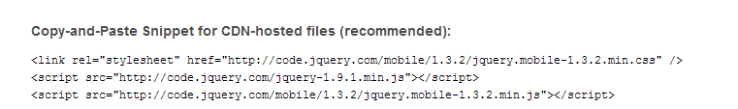

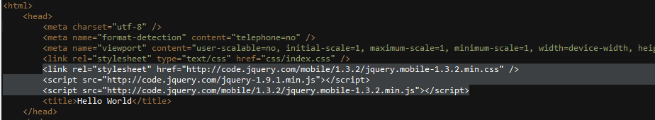

Goto jquery's demo page and look at snipets of code for any type of widget you want to include on your web page. For this app we will start with checkbox

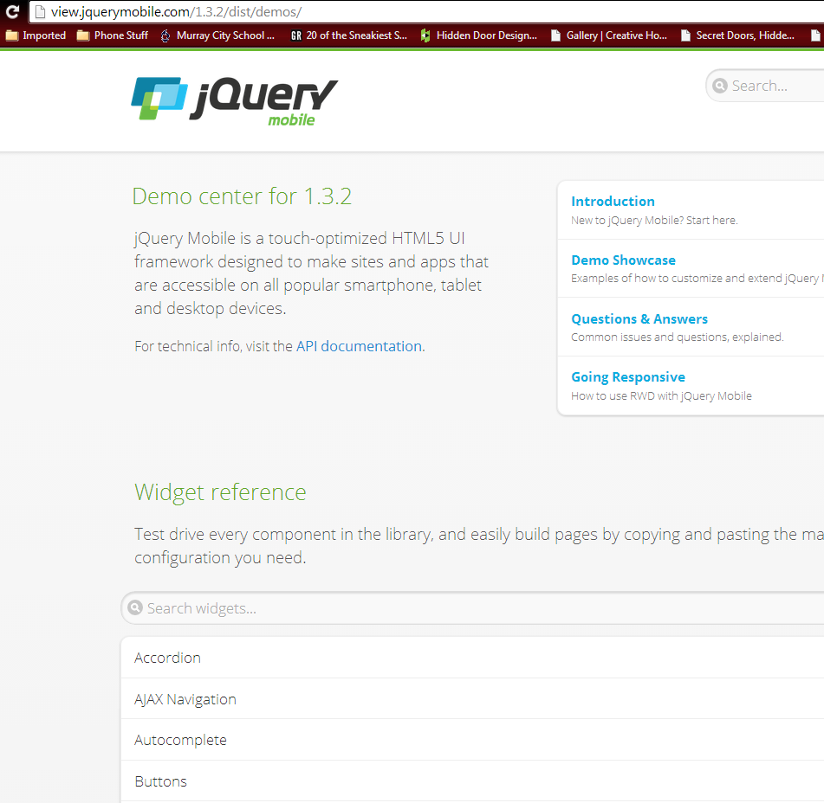

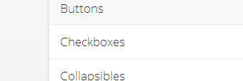

Now we find some checkboxes we want to use like vertical group and select view source

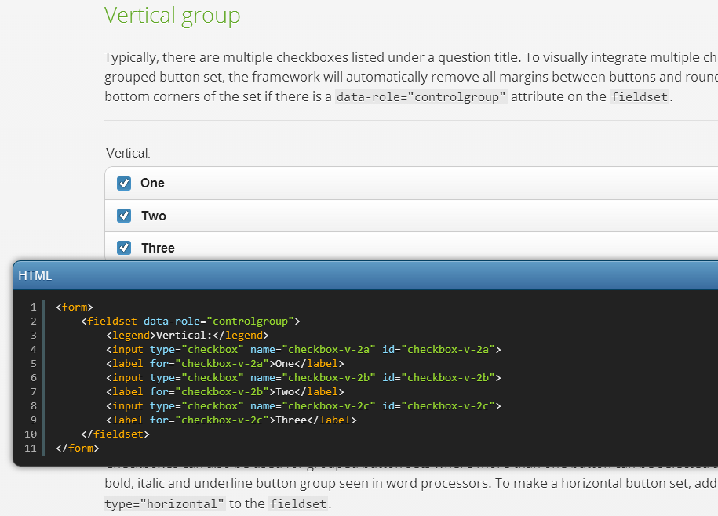

Now copy and paste this source into the body of your index.html where ever you want it to show up and you can change the title or display types of the checkboxes.

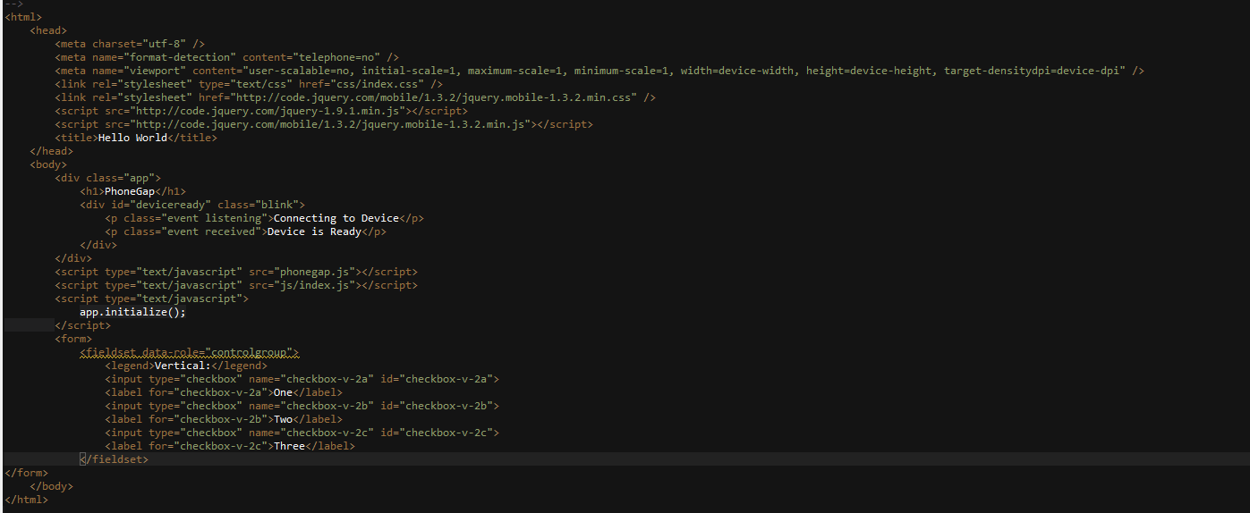

Now you can hit the play button and get a view of what your web app will look like before you have to send it to your phone.

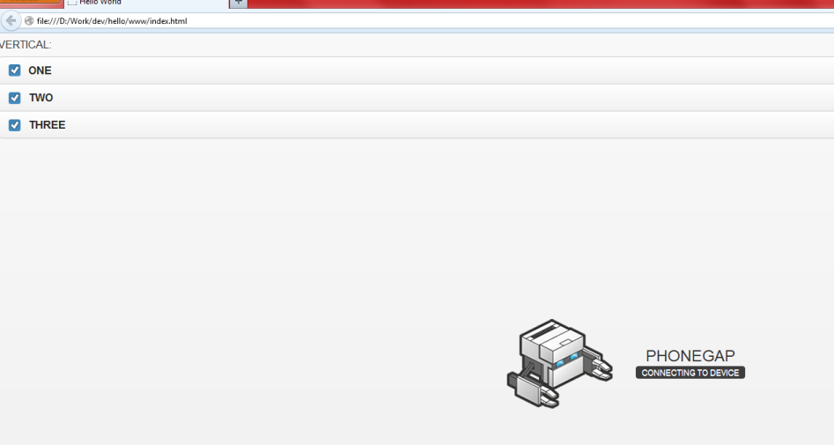

And you've added buttons.

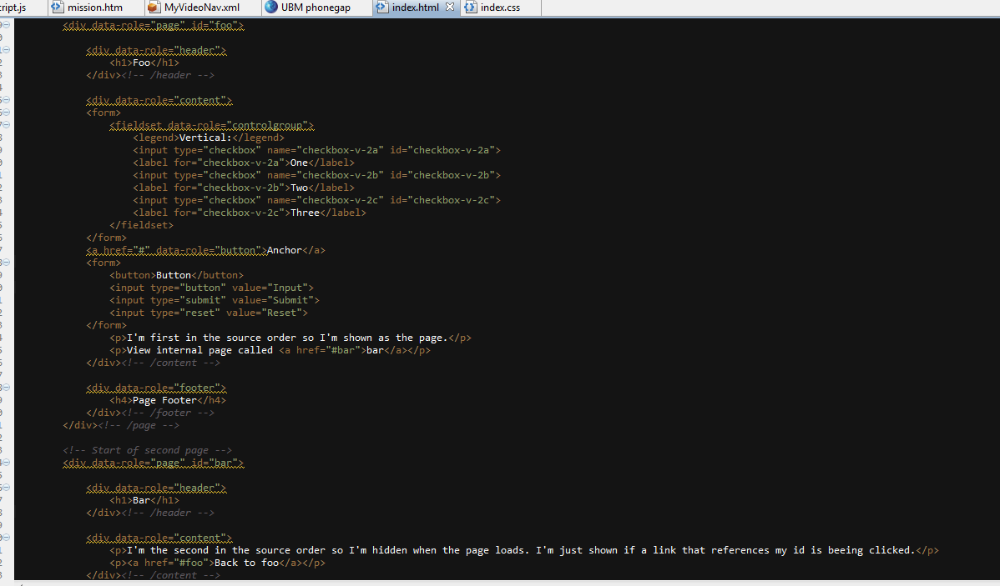

Now we've added a few pages and some submit buttons. Note the data-role="page" and the data-role="content" and "header and footer" tags.

Now we need to recompile the application and put it on phonegap's server to update to our phone.  
From command line, re-enter the command "phonegap build ios"

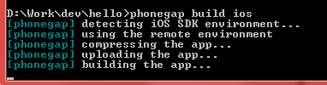

Enable Hydration with phonegap to automatically push updates made to your application to devices running the app.

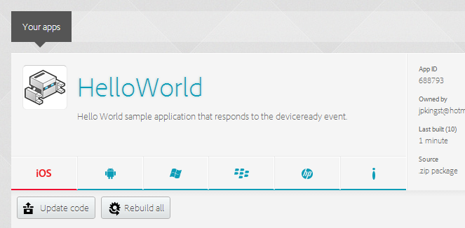

Click HelloWorld

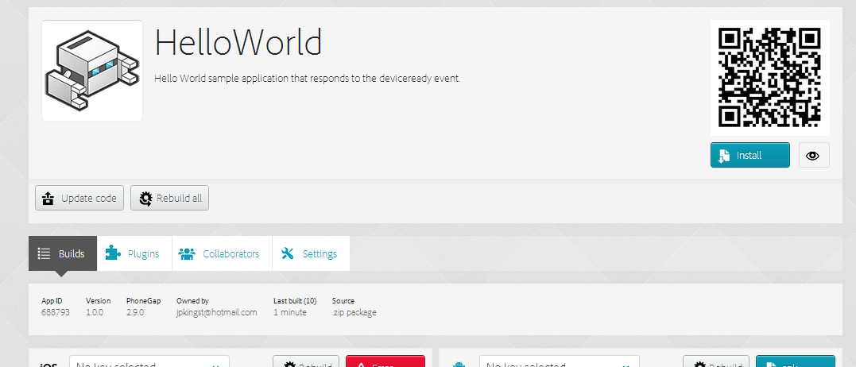

Click Settings

Check Enable Hydration

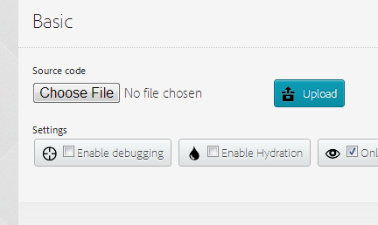

then click Save

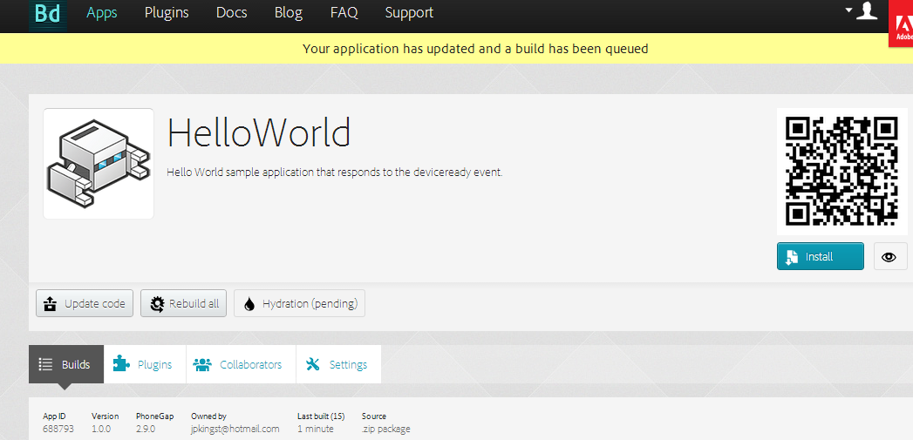

Now click Rebuild All

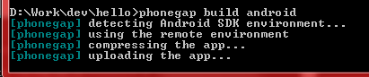

Before you can access any other pages or servers you must change the access origin in the config.xml file

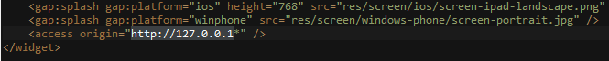

Change <access origin="*"/>



Then save your documents and redeploy

To update phonegap go to command line and type sudo npm update –g phonegap (only type sudo for mac and linux)



